

**Welcome to Penn’s Grove Library Class!**

**Class Syllabus 2024-2025 School Year**

**Librarian: Mrs. Golden-Mirarchi**

**Contact:** [**lgolden@oxfordasd.org**](mailto:lgolden@oxfordasd.org)

**Library Clerk: Mrs. Byers**

**gbyers@oxfordasd.org**

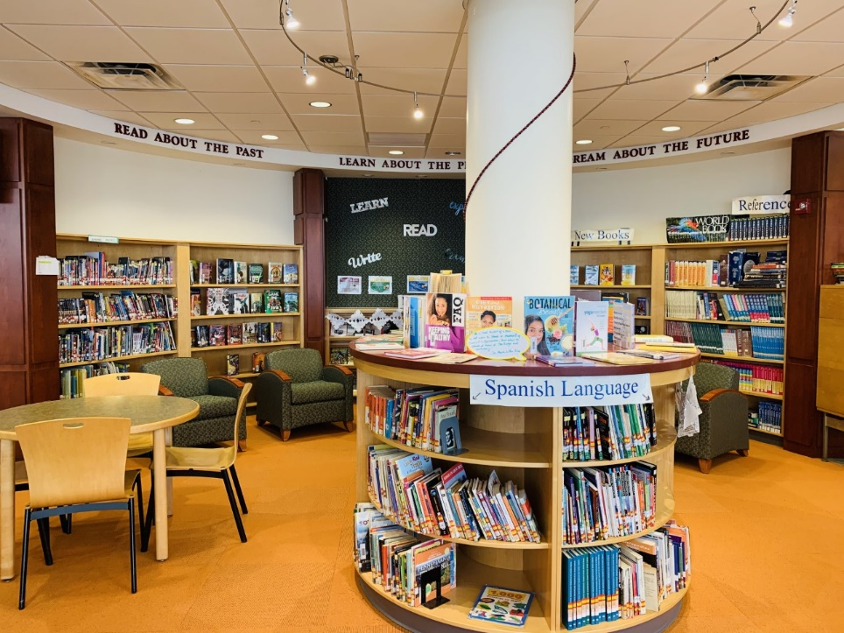

**\*Library class is built into your schedule as an elective course AND you will receive a grade on your report card- just like for any class that you attend.**

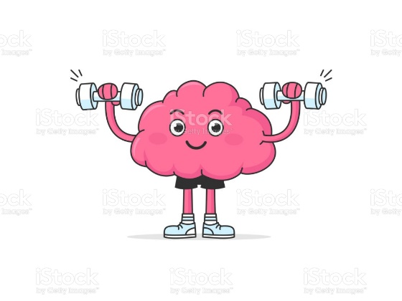

**What is covered in our class?**

**I like to describe it as, “Flexing different parts of our brain.”**

eBook Access – MackinVIA and AccessIT Library platforms.

Chester County Library System – Libby app and CCLS Library Card information.

We will review elements of the Dewey Decimal System for non-fiction.

Connect with ELA Curriculum – Poetry, Elements of fiction texts (Plot, Character analysis, etc.) and literary terminology in relation to independent reading.

STEM/STEAM Concepts – The interdisciplinary convergence of Science, Technology, Math, Engineering, and Art concepts at work.

Reliable Sources & Media Literacy – Analyze online content to make a determination if a source of information is reliable.

Craft a thesis statement for persuasive writing and learn how to support a claim with evidence.

Develop independent research skills in our look at non-fiction texts.

Check out our newest addition to the library: Our 3-D Printers & 3-D Printing Pens & ViewSonic Interactive Board!

Mrs. Golden’s Teacher Page also has information on Library Games and fun activities to help flex those brain muscles!

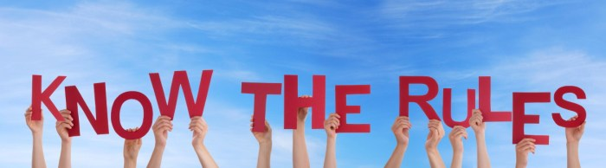

[This Photo](https://fabiusmaximus.com/2019/10/22/growth-of-regulation/) by Unknown Author is licensed under [CC BY](https://creativecommons.org/licenses/by/3.0/)

**Library Classroom Rules:**

**I WILL…**

1. Be respectful of myself, others, and school property (this includes keeping my hands and feet to myself and keeping library materials neat and orderly).
2. Use a noise-level that suits the activity (this is the library, not the gym)!
3. Be on time, ready to learn with the necessary materials needed for class.
4. Try my best and participate (in speaking, active listening, and assignments).
5. Arrive with an open mind to explore new ideas and accept challenges as an opportunity to grow.

**Grading:**

Tests/Quizzes/Performance Assessments: 70%

Formative Assessments (Classwork): 20%

Homework: 10%

We will follow the district grading scale:

**The grading scale for Oxford Area High School and Penn’s Grove School:**

|  |  |
| --- | --- |
| A+ | 97-100 |
| A | 93-96 |
| A- | 90-92 |
| B+ | 87-89 |
| B | 83-86 |
| B- | 80-82 |
| C+ | 77-79 |
| C | 73-76 |
| C- | 70-72 |
| D+ | 67-69 |
| D | 65-66 |
| F | 0-64 |

**65 is the minimum passing grade.**

**Attendance:**

Regular attendance is expected and absences will negatively impact your grade. Class assignments are expected to be completed in the allotted time during class. We will follow all attendance protocols as outlined in the student handbook.

**Microsoft Teams/Power School:**

Your report card grades come from Power School, however, we will be utilizing the Teams Platform for certain assignments. Realize that it is necessary to check Power School often to keep up with your current grade. If you have any questions about your grade, please just ask.

**Library Book Check-out:**

Recently, our district has launched a new Library Management System called AccessIT. This new platform will be the primary way you search our collection. Some great features of AccessIT include: All student’s library experience will link to your clever account, and you will be able to browse, renew a book, and build reading lists. These details will be built into our class learning time.

To check-out a book, look it up in the AccessIT catalogue to see if it is available. If the title is available, you will see a call # (which is the location or address where that materials is in the library). When you locate your book, take it up to the Information counter to have it checked out by the Librarian (Mrs. Golden) or the library clerk (Mrs. Byers). Your book will be stamped with a due date. Please be sure to return or renew your items by that date. If you need assistance, please ask Mrs. Golden (the Librarian) or Mrs. Byers (Library Clerk).

You can sign out more than one book at a time! If you approach over five books signed-out simultaneously, you will be asked to return or renew any that are over-due.

I am looking forward to a WONDERFUL school year ahead and truly look forward to getting to know you and connect you with some awesome new reads. I am hopeful that the library is a place where you can grow (and make connections to what you’re learning in other classes)!

**Make the most of your middle school experience – Read something new &**

**take pride in accepting new challenges as an opportunity to grow!**

